Adityaprava Sen

CSE 2nd year

Roll-56

Assignment on Loops-Outputs

Program 1-4 outputs-

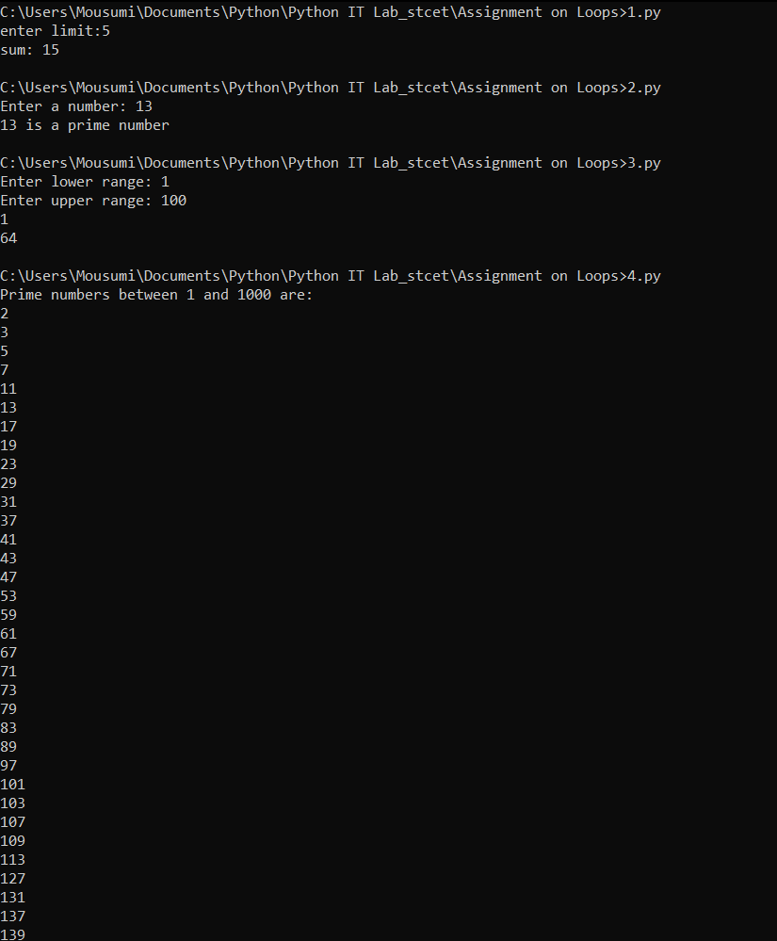

Program 5 output-

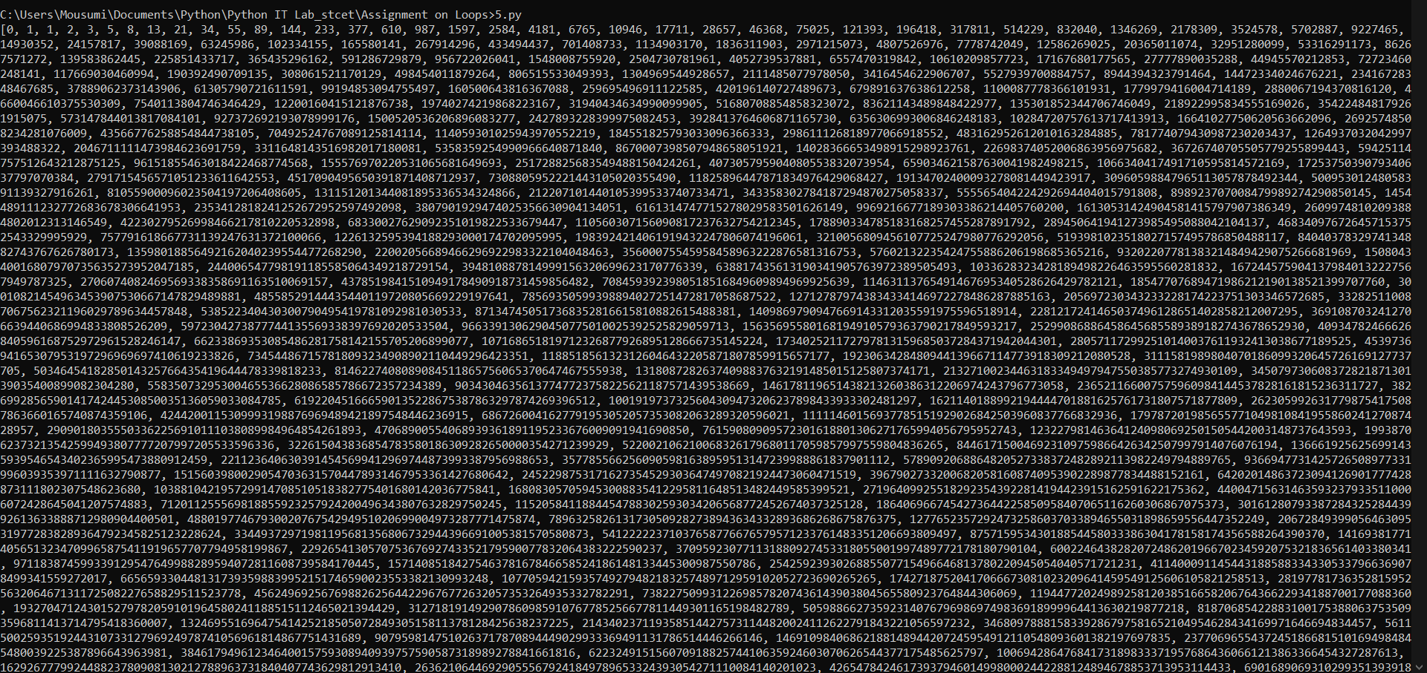

Program 6-8 outputs-

